# **Phase 4: Process Automation**

## **Validation Rules**

This set of validation rules will

* Prevent wrong data entry
* Ensure clean citizen/complaint info
* Enforce process rules (priority, approval, dates)

**Rule 1 – Complaint Description Required**

ISBLANK( Description__c )

**Error:** *"Please provide details about the complaint."*

**Rule 2– Emergency Complaints must be High Priority**

AND(

ISPICKVAL( Complaint_Type__c , "Emergency"),

NOT(ISPICKVAL( Priority__c , "High"))

)

**Error:** *"Emergency complaints must always have High priority."*

**Rule 3 – Phone Number must be 10 digits (India)**

NOT(REGEX( Phone__c , "^[0-9]{10}$"))

**Error:** *"Enter a valid 10-digit phone number."*

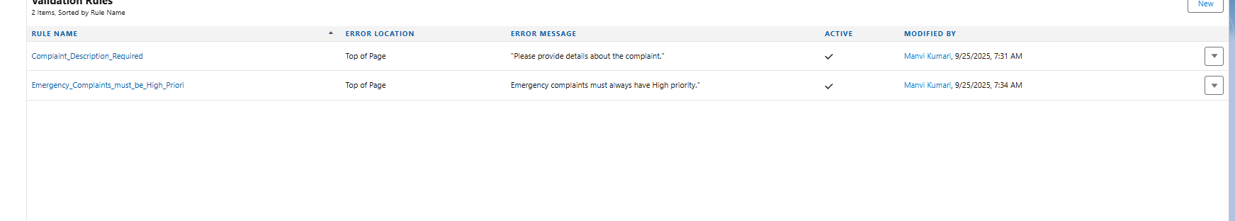

### Workflow Rules

**1. Objective / Purpose:**

Automatically send an acknowledgement email to the citizen when a new complaint is created.

**2. Trigger / Criteria:**

* **Object:** Grievance Case (Case)
* **Evaluation:** When record is created
* **Rule Criteria:**
  + Name = New
  + Priority Level = High or Medium
  + Complaint Type = Emergency or Normal

**3. Workflow Action:**

* **Action Type:** Email Alert
* **Email Template:** Complaint Acknowledgement Email
* **Recipient:** Citizen (Contact Email)

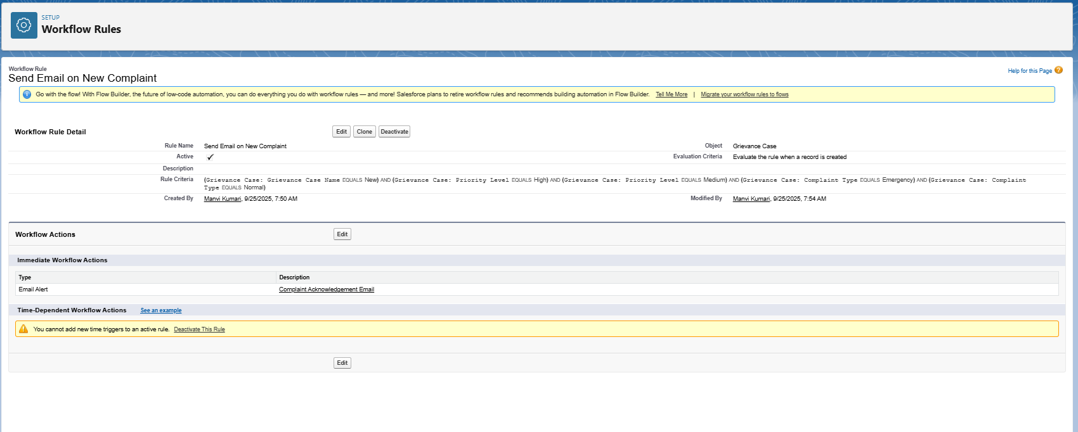

### **Process Builder**

**Step-by-Step: Legacy Process BuildAer for Cases**

**Step 1 – Go to Process Builder**

1. Setup → Search **Process Builder** → Click **New**.
2. **Name:** Auto-update Case Status
3. **API Name:** Auto_Update_Case_Status
4. **Description:** Automatically updates Case status when a new complaint is logged.
5. **The process starts when:** A record changes → select **Case** (Grievance Case).

**Step 2 – Define Criteria**

* **Criteria Name:** New Complaint
* **Criteria for Executing Actions:** Conditions are met
* **Conditions Example:**
  + Field = Status
  + Operator = Equals
  + Value = New
* **Advanced:** Execute actions only when criteria are met

**Step 3 – Add Immediate Action**

* **Action Type:** Update Records
* **Action Name:** Set Complaint Status to “In Progress”
* **Record Type:** Select the Case that triggered the process
* **Field to Update:** Status → In Progress

**Step 4 – Activate**

* Save the process → Click **Activate**

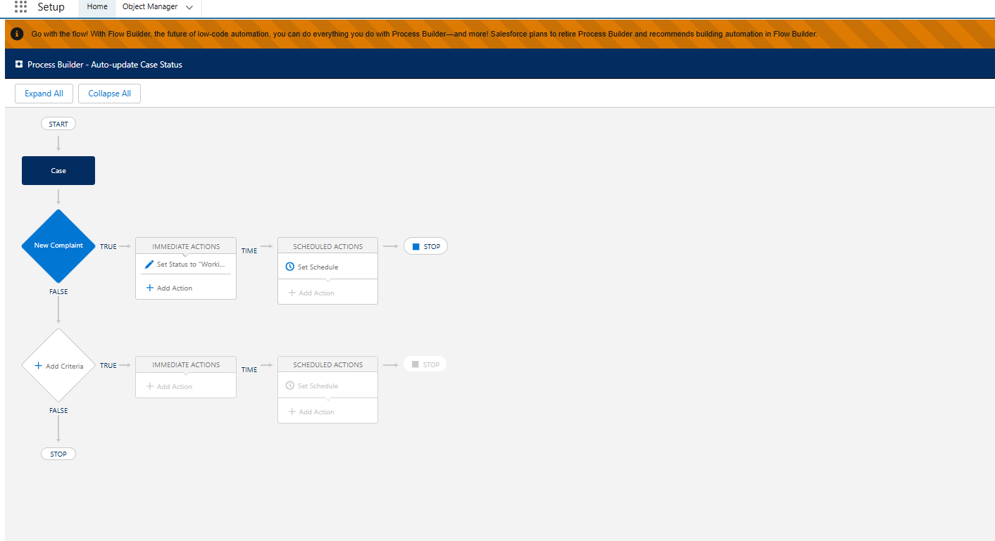

### Approval Process

**Step 1 – Go to Approval Processes**

1. Setup → Search **Approval Processes** → Click **Create New Approval Process**.
2. Select object: **Case** (your GrievEase Case object).
3. Use **Standard Setup Wizard**.

**Step 2 – Name & Description**

* **Process Name:** High-Priority Complaint Approval
* **Unique Name:** High_Priority_Case_Approval
* **Description:** Sends high-priority or high-impact complaints to manager for approval.

Step 3 -

| **Field** | **Operator** | **Value** |  |
| --- | --- | --- | --- |
| Case: Priority | Equals | High |  |
| OR Case: Complaint Type | Equals | Emergency |  |
|  |  |  |  |

**Step 4 – Assign Approver**

* **Step Name:** Manager Approval
* **Assigned To:** Manager (lookup role or specific user)
* Options: Automatically assign to the manager of the **record owner** or a predefined manager.

**Step 5 – Initial Submit Actions**

* Lock the case to **prevent edits while pending approval**
* Optional: Send email notification to **manager**

**Step 6 – Approval Actions**

* **If Approved:**
  + Update Case Status → Approved / In Progress
  + Optional: Notify the citizen via email alert
* **If Rejected:**
  + Update Case Status → Rejected / Escalated
  + Optional: Notify citizen

**Step 7 – Activate**

* Save → Activate the approval process.
* Now, any **high-priority / high-impact complaint** automatically triggers **manager approval**.

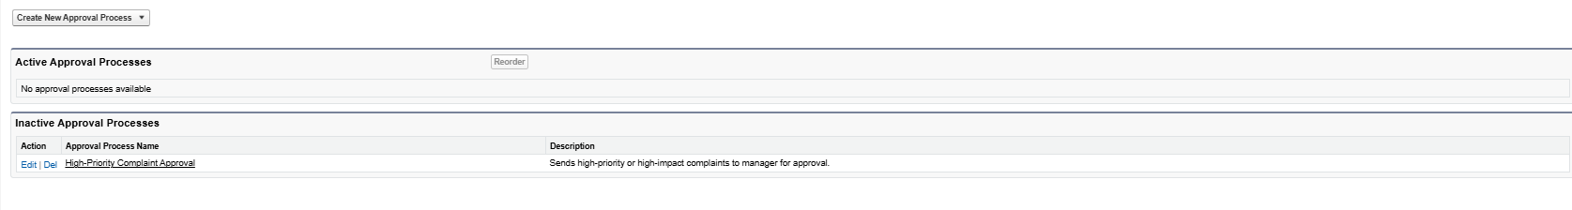

### **Flow Builder**

**Screen Flow: Citizen Complaint Submission**

**Purpose:** Allow citizens to submit complaints via a user-friendly form.

**Steps:**

1. **Start a Screen Flow**
   * Go to **Setup → Flow → New Flow → Screen Flow → Freeform**
2. **Add Screen Element: Complaint Details**
   * Fields to include:
     + **Citizen Name** (Text / Lookup)
     + **Complaint Type** (Picklist: Sanitation, Road, Water, etc.)
     + **Description** (Long Text)
     + **Upload Documents** (File Upload)
     + **Priority** (Picklist: Low, Medium, High)
3. **Add Assignment Element (Optional)**
   * Set default values:
     + Status = New
     + Submission Date = Today()
4. **Create Records Element**
   * Object: Complaint__c
   * Map screen input fields + assignment values
5. **Add Confirmation Screen**
   * Display message:  
     "Your complaint has been submitted successfully! Complaint ID: {!RecordId}"
6. **Save & Activate Flow**

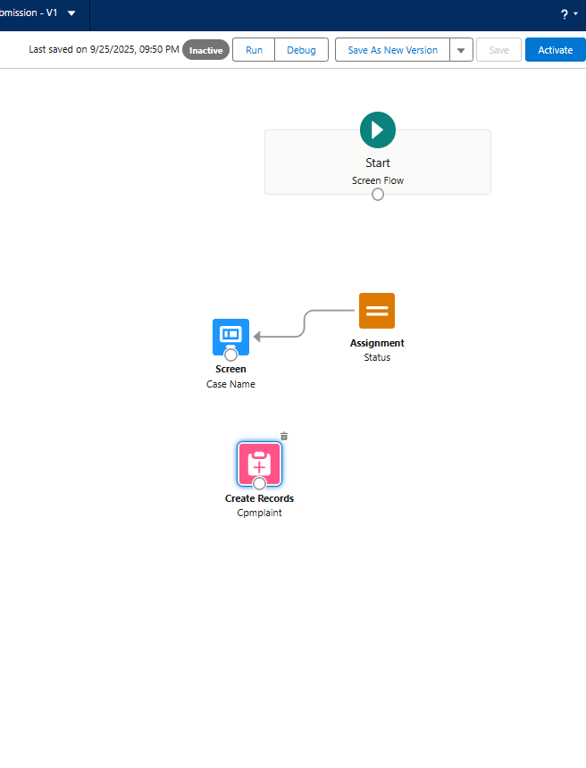

### Email Alert

**Scenario:**

Send a **confirmation email to the citizen** once their complaint or service request is **approved** by the officer or manager.

**1️⃣ Create an Email Template**

1. Go to **Setup → Email Templates → New Email Template**
2. Select **Type:** HTML or Custom (without letterhead)
3. Fill in the fields:
   * **Template Name:** Complaint_Approval_Notification
   * **Subject:** "Your Complaint/Request has been Approved"

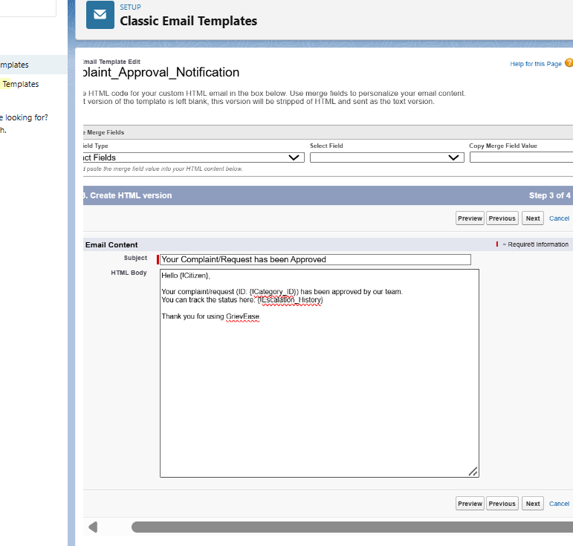

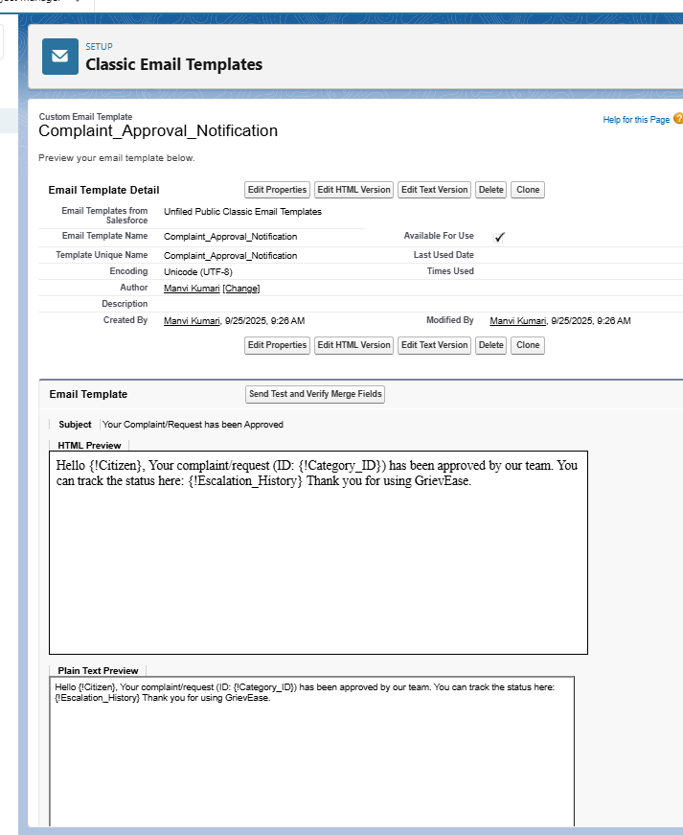

### **Field Updates**

**Steps in Flow Builder:**

1. **Go to Flow Builder → New Flow → Record-Triggered Flow**
   * Object: Booking__c
   * Trigger: **A record is updated**
2. **Set Entry Conditions**
   * Field: Approval Status = Approved
   * Optionally, Booking Status != Confirmed (to prevent unnecessary updates)
3. **Add Update Records Element**
   * Label: Update Booking Status
   * Record to Update: **Triggering Record**
   * Field Update:
     + Booking Status = Confirmed
4. **Connect Elements & Save**
5. **Activate the Flow**

### **Tasks**

Go to **Setup → Workflow Rules → New Rule**

* Object: Case

**Set Rule Criteria**

* Approval Status = Approved

**Add Workflow Action → New Task**

* Subject: "Handle Case"
* Assigned To: Agent/Owner
* Related To: Case
* Status: Not Started
* Priority: High
* Due Date: Today() or SLA-based

**Activate the Workflow Rule**

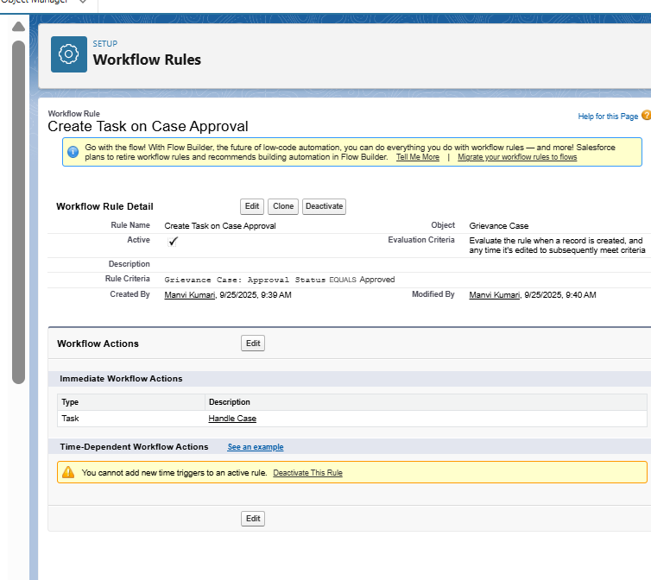

### **Custom Notification**

**Create a Custom Notification Type**

1. Go to **Setup → Notification Builder → Custom Notifications → New**
2. Fill in:
   * **Name:** Case_Approval_Notification
   * **API Name:** Case_Approval_Notification
   * **Supported Channels:** Desktop and Mobile
   * **Description:** "Notifies the agent when a case/booking is approved"
3. Save

